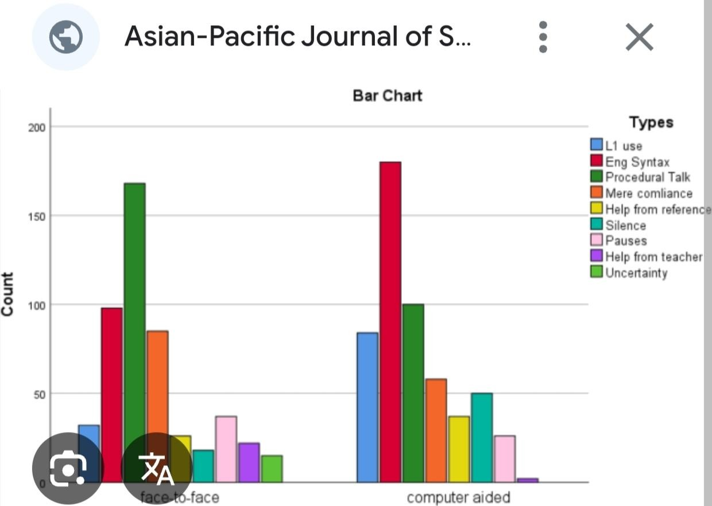

1. **Final Deliverables**
   * Final Jupyter/Colab Notebook (cleaned and well-commented)
   * Dashboard file or link (Power BI/Tableau/Plotly Dash)
   * Final Report (PDF/DOC format)

def display_statistics(df):

stats = calculate_statistics(df)

s

t.subheader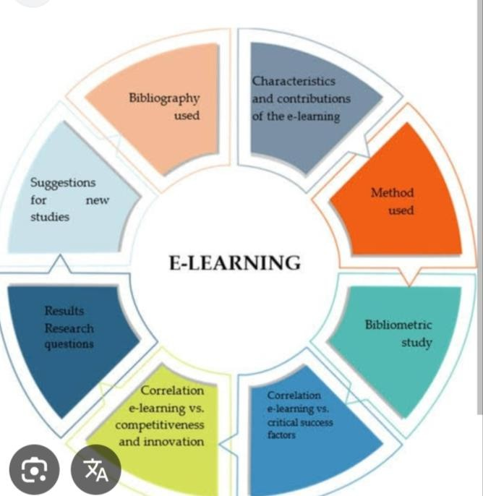 ("Basic Statistics")

for stat, value in stats.items(): st.write(f"{stat.replace('_', ' ').title()}: {value:.2f}")

def plot_engagement_distribution(df): """Plot engagement time distribution."""

st.subheader("Engagement Time Distribution") fig, ax = plt.subplots()

sns.histplot(df['engagement_time'], kde=True, ax=ax) st.pyplot(fig)

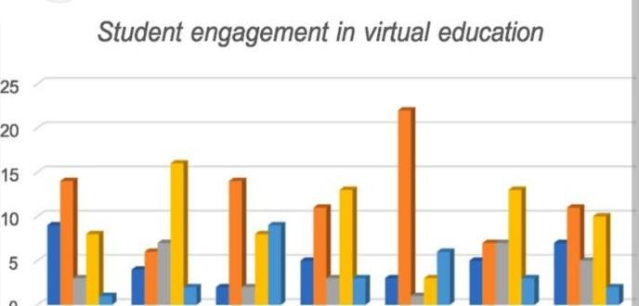

**15. Team Members and Roles**

|  |  |
| --- | --- |
| **Name** | **Responsibility** |
| [Suji.M] | Data collection and preprocessing |
| [Sathya priya.M] | Exploratory data analysis and modeling |
| [Saridha.S] | Dashboard  development and visualization |